|  |  |  |  |
| --- | --- | --- | --- |
| **Lyng Primary School Knowledge Organiser** | | | |
| **Topic:** | **The Maya**  **Why are rainforests important to us?** | Year 4  Battles, beliefs and buildings | Autumn - Spring |

 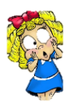

**Background information for parents and teachers**

The Maya civilisation began long ago in a place called '**Mesoamerica**'. This huge area is made up of Mexico and part of Central America. Maya culture shared many characteristics with other Mesoamerican cultures such as the Olmec, Zapotec or Aztec, but retained some features purely Mayan. Mayans lived in southern Mexico and northern Central America including Guatemala, El Salvador, Honduras and Belize. This area includes the northern lowlands, central lowlands and southern highlands. These areas include rainforests, savannas, semi-arid highland plateaus, semi-alpine peaks and swampy low areas. Such an array of landscapes is host to a rich diversity of wildlife and plants; Maya culture adapted creatively to this diverse natural world. The Mayas built amazing cities like **Tikal** (which they called 'Yax Mutal') and **Palenque.**

Nowadays, forests which the Mayans lived so comfortably are changing due to global issues such as deforestation.

|  |  |
| --- | --- |
| **What Step On and Goldilocks words will I use?** | |
| **Spelling** | **Definition** |
| Chichen Itza | a village in Yucatán state in Mexico: site of important Mayan ruins. A UNESCO World Heritage Site |
| civilisation | a human society with its own social organisation and culture |
| continent | a very large area of land that consists of many countries. South America is a continent |
| climate | the general weather conditions that are typical of a place |
| deforestation | if an area is deforested, all the trees there are cut down |
| distribution | delivering goods to a number of places |
| economy | A country's economy is the wealth that it gets from business and industry |
| emergent | Tall trees growing above the canopy |
| Forest | A region is a large area of land that is different from other areas of land |
| Maya | a member of an indigenous people of Yucatan, Belize, and N Guatemala, having an ancient culture once characterized by outstanding achievements in architecture, astronomy, chronology, painting, and pottery |
| Mayan | of, relating to, or characteristic of the Maya or any of their languages/  a family of Central American languages |
| Mesoamerica | Another name for central America |
| natural resources | resources  the land, forests, energy sources and minerals existing naturally in a place that can be used by people |
| nomadic | Nomadic people travel from place to place rather than living in one place all the time |
| pollution | he process of polluting water, air, or land, especially with poisonous chemicals |
| Temple | A building used for the worship of a god or gods |
| trade | the activity of buying, selling, or exchanging goods or services |
| Under storey | Trees just below the canopy |
| vegetation | plants, trees and flowers |

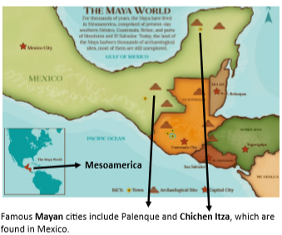

**Fieldwork Opportunities**

**Wyre Forest- Looking at the forest and fauna and** comparing to a Mayan rainforest

**Cadbury World-** A tour of a Mayan village, to experience how Mayans lived. A look into rainforests and deforestation and fairtrade..

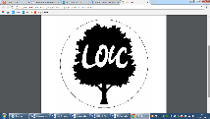

|  |
| --- |
| **Geographical study** |
| Compare Wyre Forest to a rainforest  Ask and answer geographical questions about the physical and human characteristics of a location.  Explain own views about a location, giving reasons.  Use maps, atlases and globes to locate countries and describe features.  Use fieldwork to observe and record the human and physical features in the local area (Wyre Forest).  Use a range of resources to identify the key physical and human features of a location.  Describe the geographical similarities and difference between countries. |

**Significant places**

* Wyre Forest
* Copán – Honduras. (Ancient Mayan City)
* Chichen Itza (City with a Mayan temple) – Mexico
* Yucatán Peninsula,
* Mexico
* Cadbury World, Bournville

**Our Storytelling Approach to enhance engagement**

|  |  |  |
| --- | --- | --- |
| **People:**  Mayan tribe | **Place:**  Rainforest | **Problem:**  Should we go to battle? Who should rule? |

**Key facts and locations**

**Map to be studied**

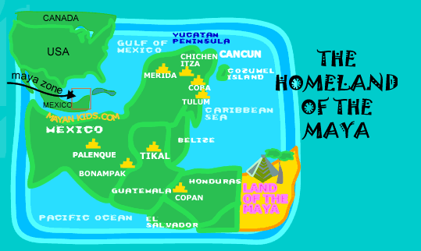

The Mayans lived in Central America (Mesoamerica)

South America is the continent in which the Mayans lived.

The climate of South America is different to the UK.

The rainforest has trees in which animals live, however due to deforestation and the desire for the natural resources, this is now changing at a fast rate.

Erosion, deforestation and pollution have a negative impact on the environment.

Mayan cities had similar layouts to each other. They would have a palace for the ruler, a plaza for the marketplaces and temples, in the form of pyramids.

Maya cities were often found near trade routes and good farmland.  
  
The demise of the Mayan civilisation came about because of a mixture of deforestation, land erosion and drought.

Mayan ruins are still around today and so are some of the trade that they shared globally.

**Agreed Outcome**

A comparative understanding of the difference between the Wyre Forest, England and the rainforest.

Also, to have an awareness of global issues, such as deforestation and palm oil.

|  |  |  |  |
| --- | --- | --- | --- |
| **Lyng Primary School Knowledge Organiser** | | | |
| **Topic:** | **Mayans**  **Human and Physical Geography** | Year 4  *Battles, Beliefs and Buildings* | Autumn- Spring |

|  |  |  |
| --- | --- | --- |
| 5. Palm oil is an example of a… | **S** | **E** |
| 1. natural resource |  |  |
| 1. banned product |  |  |
| 1. global |  |  |

|  |  |  |
| --- | --- | --- |
| 6. Fairtrade is important because…(tick all that apply) | **S** | **E** |
| 1. makes sure that labour wages are fair |  |  |
| 1. ensures local communities are treated fairly |  |  |
| 1. it gives us a lot of deforestation |  |  |

|  |  |  |
| --- | --- | --- |
| 7. Name 3 differences between the Wyre Forest and the rainforest | **S** | **E** |
| ______________________________________ ______________________________________ ______________________________________ |  |  |

|  |  |  |
| --- | --- | --- |
| 8. Deforestation led to the demise of the Maya people. This is because | **S** | **E** |
| 1. the land became less fertile |  |  |
| 1. there was nowhere for the animals to live |  |  |
| 1. it caused pollution |  |  |

|  |  |  |
| --- | --- | --- |
| 1. Which continent does not have a rainforest? | **S** | **E** |
| 1. Antartica |  |  |
| 1. South America |  |  |
| 1. Europe |  |  |

|  |  |  |
| --- | --- | --- |
| 2. What does the word Mesoamerica mean? | **S** | **E** |
| 1. South America |  |  |
| 1. North America |  |  |
| 1. Central America |  |  |

|  |  |  |
| --- | --- | --- |
| 3. Give a feature of a Mayan city? | **S** | **E** |
| ______________________________________ ______________________________________ |  |  |

|  |  |  |
| --- | --- | --- |
| 4. Deforestation causes… | **S** | **E** |
| a) loss of biodiversity |  |  |
| b) great woodlands |  |  |
| c) a rich environment where animals live |  |  |